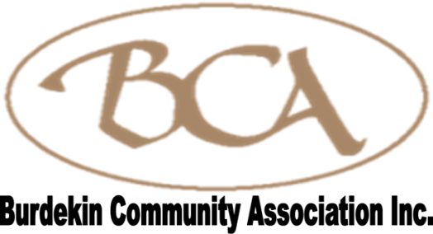
Flexible Financial Hardship Fund

The Burdekin Community Association Inc. has been contracted by the Department of Communities, Disability Services and Seniors to deliver a Flexible Financial Hardship Fund to residents in drought declared areas of the Burdekin Shire.

Assistance of up to $1500 is available to assist with household and property costs to ease the burden on drought affected residents. We recognise that the amount available to households is relatively small; however we hope the contribution is of some support in easing the financial hardship to families and businesses as a result of the drought.

Applications will be considered from drought affected residents to assist with freight costs for reducing/restocking of stock numbers and fodder for stock, utilities (power, phone, fuel, etc), school fees, rates and other costs.

The maximum amount available per household/property address is $1,500 (excluding GST) per application, supported by an invoice/receipt of the expense.

To be eligible you must reside in the Burdekin Shire (proof of residency must be provided).

In the application you will be asked some questions to help us understand the full impact of the drought on community resilience and if we can include you in future communications in relation the future community drought resilience activities.

If you wish to apply please email your Application Form to bca@bcaburdekin.org.au, Post to PO Box 815, Ayr QLD 4807 or Fax: (07) 4783 3990. Applications will not be able to be accepted once total grant funding has been expended, on or before 28 February 2019.

For queries please contact Rebecca Grogan on Ph: 07 4783 3744.

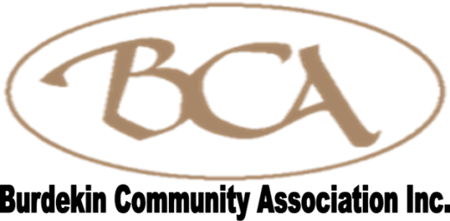
Flexible Financial Hardship Fund
APPLICATION FORM

Please complete and sign this form, then send as an email attachment to bca@bcaburdekin.org.au, Post to PO Box 815, AYR Q 4807, deliver to the Support Centre, 130 Queen St, AYR Q 4807 or fax (07) 4783 3990.

NAME:
AFFECTED ADDRESS/PROPERTY:
AMOUNT REQUESTED:
POSTAL ADDRESS:
POST CODE: NO. DEPENDENTS:
PHONE: MOBILE:
EMAIL:
Banking details are required to facilitate payments if successful.
BSB: ACCOUNT:
Account Name:

Has your property been drought declared? Yes / No

What is your primary source of income?.......................................................................

Do you receive a government allowance? Yes/ No
If yes what type: ……………………………………………………………………………….

Please briefly describe your circumstances, and the impact the drought has had on your primary source of income:……………………………………………………………………………………………
…………………………………………………………………………………………………………………
…………………………………………………………………………………………………………………
…………………………………………………………………………………………………………………
…………………………………………………………………………………………………………………
…………………………………………………………………………………………………………………
…………………………………………………………………………………………………………………
…………………………………………………………………………………………………………………
…………………………………………………………………………………………………………………

Applications will be considered from drought affected residents to assist with eligible bills/accounts power, phone, communications, school fees, grocery bills, fuel bills, insurances, vehicle registration and rates but is not limited to these expenses.

A copy of invoices/receipts for current expenses from the applicant are required for the assessment process and will be subject to approval by the Burdekin Community Association Inc.

Assistance of up to $1,500 (excluding GST) per application and one application per household/property address will be considered.

Please check claimed expense:
 FUEL
 POWER
 PHONE
 SCHOOL FEES
 RATES
 OTHER (details required)……………………………………………………………………………………………………………………………………………

Would you like to receive future communications in relation to Community Drought resilience activities? Yes / No

I declare the information in this form to be true and correct. I understand that information provided in this application may be used to assist in reporting purposes, in a de-identified format, to meet the needs of the funding agreement. BCA shall operate in accordance with the Privacy Act 1998.

Name:

Signature:

Date:

BCA OFFICE USE ONLY
DATE RECEIVED: DATE ASSESSED:
ASSESSMENT OUTCOME: SUCCESSFUL / UNSUCCESSFUL:
NOTIFICATION DATE: PAYMENT DATE:

